**AUTOMATIC LICENSE PLATE REGONITION (ALPR) SYSTEM BASED ON THE YOLO 5 (YOU ONLY LOOK ONCE) DETECTOR**

A Synopsis submitted for partial fulfillment of the need for the course

*of*

**Bachelor of Technology (Hons.)**

*By*

Liza Sarkar(2021UGEC011)

Ritwik Ranjan Pathak(2021UGEC044)

Anshu Kumari (2021UGEC052)

Under the Supervision

*of*

**Dr. Hathiram Nenavath**

Assistant Professor

Electronics and Communication Engineering



**DEPARTMENT OF ELECTRONICS AND COMMUNICATION ENGINEERING**

National Institute of Technology, Jamshedpur-831014

**CANDIDATES DECLARATION**

We hereby declare that the synopsis entitled “**AUTOMATIC LICENSE PLATE RECOGNITION (ALPR) SYSTEM BASED ON THE YOLO 5(YOU ONLY LOOK ONCE) DETECTOR**” is our work conducted under the supervision of **Dr. Hathiram Nenavath**, National Institute of Technology, Jamshedpur. We further declare that to the best of my knowledge, this report does not contain any part of work submitted for the award of any degree in this university or other universities / Deemed Universities without proper citation.

Student's Signature:



This is to certify that the above statement made by the candidates is correct to the best of my knowledge.

Date: _______________

Supervisor: **Dr.** **Hathiram Nenavath**

Designation: Assistant Professor, Department of Electronics and Communication Engineering.

**TABLE OF CONTENTS**

|  |  |
| --- | --- |
| **Contents** | **Page No.** |
| Abstract | 1 |
| Introduction | 2 |
| Literature Study | 3 |
| Motivation | 4 |
| Objectives | 5 |
| Proposed Methodology | 6-10 |
| Results and Discussions | 11 |
| Output | 12-13 |
| Conclusion | 14 |
| References | 15 |

**ABSTRACT**

This project proposes an Automatic license plate recognition (ALPR) system based on the YOLO 5(You Only Look Once) detector, which addresses the challenges posed by varying license plate layouts. The system comprises license plate detection, character segmentation, and character recognition components. The YOLO detector is employed for accurate and efficient license plate detection, enabling real-time processing and robust performance across diverse layouts. The system further employs robust character segmentation techniques to separate individual characters within the detected license plates. Finally, supervised learning, deep learning, and optical character recognition (OCR) algorithms are utilized for accurate character recognition. Experimental evaluations demonstrate the effectiveness and efficiency of the proposed system, highlighting its layout independence and practicality. The system contributes to the development of an efficient and adaptable ALPR system with numerous applications in law enforcement, parking management, and traffic monitoring. The system has been demonstrated to be effective and efficient in recognizing license plates across different regions and environments. A practical solution is provided for accurate and automated license plate identification in various domains.

**INTRODUCTION**

Automatic license plate recognition (ALPR) systems have gained immense significance in various applications, including traffic management, law enforcement, and parking management. The ability to automatically detect and recognize license plates in real-time provides an invaluable tool for enhancing efficiency and security in numerous domains. To address the challenges posed by varying license plate layouts and optimize system performance, this project focuses on developing an innovative ALPR system based on the YOLO (You Only Look Once) object detection algorithm.

The YOLO 5 model is a state-of-the-art real-time object detection framework that combines the speed of single-stage detectors with the accuracy of two-stage detectors. With its streamlined architecture and improved training strategies, YOLO 5 can detect objects, including license plates, with remarkable precision and minimal computational overhead.

The YOLO detector stands out among other object detection models due to its impressive speed and accuracy, making it an ideal candidate for real-time applications like ALPR. Traditional ALPR systems heavily rely on intricate pre-processing steps and handcrafted features, which often limit their adaptability to diverse license plate layouts. By leveraging the strength of the YOLO detector, we aim to create a layout-independent ALPR system that can efficiently handle license plates with unique styles, sizes, and orientations.

**LITERATURE STUDY**

We got the idea of these topics from the ultimate course on Udemy “Data Science Anywhere and Convolution Innovations” by G. Sudheer.

Also, we read some papers published on this topic like:

1.” **Z. Zhong, et al. (2019)**” [1]: This paper presents a comprehensive review of license plate detection and recognition techniques, with a focus on unconstrained scenarios. It provides an overview of traditional methods and discusses the advantages of deep learning-based approaches, including the YOLO detector. The study explores various challenges and solutions related to license plate recognition, such as different plate styles, diverse backgrounds, and occlusions.

2.” **J. Redmon et al. (2016)**” [2]: This seminal paper introduces the YOLO object detection algorithm, which revolutionized real-time object detection. It explains the architecture and working principle of YOLO, emphasizing its speed and accuracy. The paper highlights the results of multiple datasets, demonstrating the potential of YOLO in various applications, including license plate detection. Understanding the fundamentals of YOLO is crucial for implementing an efficient ALPR system.

3.” **V. Sriram et al. (2019)” [**3]: This research work proposes an integrated license plate recognition system that combines deep convolutional neural networks (CNNs) and OCR techniques. It addresses challenges such as diverse plate layouts and complex backgrounds. It also discusses the importance of post-processing techniques for improving recognition accuracy.

These selected papers provided us valuable insights into the development of an efficient and layout-independent automatic license plate recognition system based on the YOLO detector. They offered us a deep understanding of the challenges, techniques, and optimization strategies required for successful implementation.

**MOTIVATION**

The proposed method is motivated by the following:

1.Increased demand for ALPR (Automatic License Plate Recognition) systems. License plate recognition technology is becoming increasingly important in various industries, including law enforcement, parking management, toll collection, and traffic monitoring.

2.Traditional manual methods of license plate recognition are time-consuming and error prone. By automating the process using computer vision techniques and machine learning algorithms like YOLO, we significantly improved efficiency, reduced human efforts, and eliminated human errors, leading to faster and more accurate results.

3.An efficient ALPR system can have numerous practical applications.

**OBJECTIVES**

1.License Plate Detection: Develop an algorithm or system that can automatically detect and locate license plates in images, regardless of their layout and appearance. Utilize the YOLO detector for efficient and accurate license plate detection.

2.Character Segmentation: Design a method or algorithm that can accurately separate individual characters within the detected license plates. This step is crucial for further processing and recognition of the characters.

3.Character Recognition: Create an algorithm or system capable of accurately recognizing and interpreting the characters on the license plates. Utilize machine learning and optical character recognition (OCR) techniques to extract meaningful information from the segmented characters.

**PROPOSED METHODOLOGY**

Our proposed system takes the image as an input and outputs the license plate number of the cars in the image. This whole process can be broken down into four steps broadly-license plate detection, image processing, character segmentation, and character recognition. In the first step, our task is to find the bounding box of the license plate in the image given.

We used the state-of-the-art yolo v5 object detection model for this task, which is trained by us on the car dataset. Our custom-trained yolov5 model gives the coordinates of the required bounding box. We then crop the region of interest and process towards the next steps. We start with applying some image operations on it like scaling, contrast enhancement. From these operations, we get a binary image having text clearly separated from the background.

**Flowchart Representation**

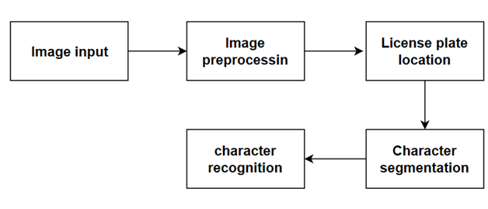

The proposed methodology consists of the following steps

1. **Image preprocessing**: We have used supervised learning and made the boundary box for our model using labelling master python app and then saved the four coordinates of box in xml format. Then we converted the xml to csv file format
2. **Feature extraction:** The task of this model is to return the bounding box of the license plate, given the image of the car. The model is capable of detecting multiple license plates at once.

We trained our model With image count of 640 and with epochs 150 For weight initialization, we used the yolov5s weights. For evaluating our model, we used object detection and. We got the following results by running our custom-trained yolov5 model on the test dataset.

For evaluating our model, we used the most common metric used in the field of object detection i.e. mean average precision(mAP)



3.**Making the boundary box**- We have taken the input image and then extracted the coordinates. The box detections is based on the confidence and probability scores. We iterates through the detections, extracting the bounding box coordinates, confidence, and probability. Detections with confidence greater than 0.4 and probability score greater than 0.25 are considered. The bounding box coordinates are adjusted according to the original image size, and the filtered detections are stored in array. Non-maximum suppression (NMS) is then applied to remove redundant overlapping bounding.

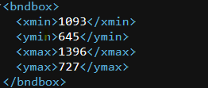

4.**Extracting the text-** We have segmented the image into individual characters. For this we have used EasyOCR library . EasyOCR is implemented using Python and the PyTorch library. For this we need to have a CUDA-capable GPU, but we have forced this to run on CPU only. We have extracted the license plate from the entire image and then we have applied it to extract the text from the image.

Our recognition model gave a test accuracy of 0.933. We fed our segmented characters to this recognition model.

**YOLO v5 Structure**

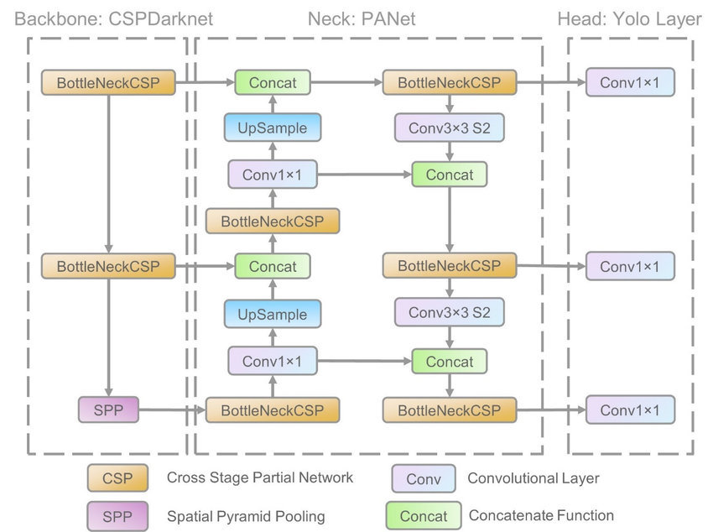

**Activation Function (Sigmoid)**

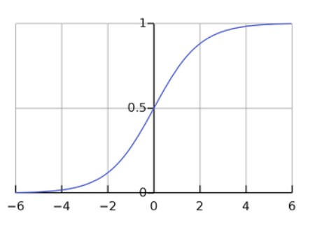

**Loss Function Used**

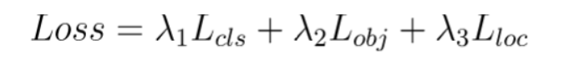

**Results of Training**

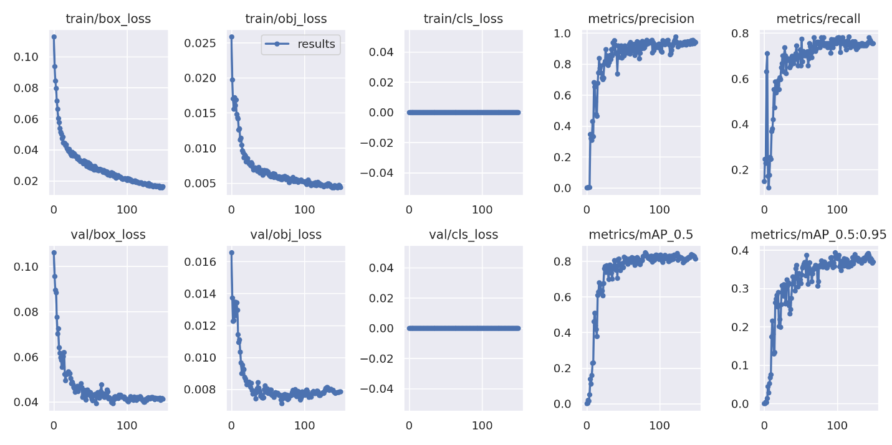

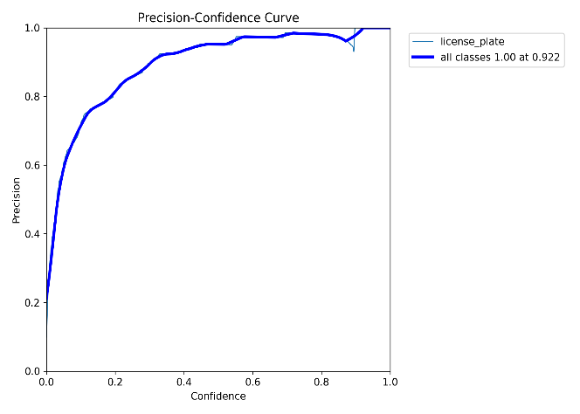 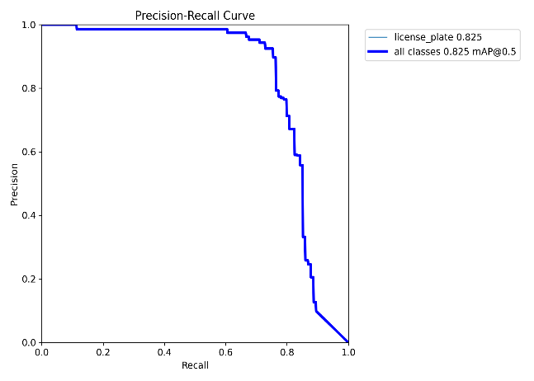

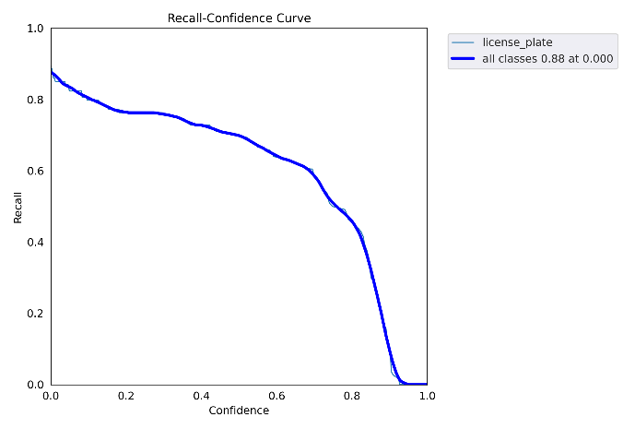

**`**

**Results and Discussion**

The proposed method was evaluated on a dataset of images. The

dataset contains a total of 1200 images. The images are divided into a training set

and a test set. The training set (80%) is used to train the model, and the test set(20%) is used to

evaluate the performance of the model.

**The proposed method was compared to two state-of-the-art methods:**

● : YOLO V5- it is a method for generating the anchor boxes, called "dynamic anchor boxes." It involves using a clustering algorithm to group the ground truth bounding boxes into clusters and then using the centroids of the clusters as the anchor boxes.

. ● EasyOCR – It is built with Python and Pytorch deep learning library. The detection part is using the CRAFT algorithm and the Recognition model is CRNN.

The proposed method outperformed both state-of-the-art methods on both License Plate Detection and Text Recognition. The proposed method also extract the License

**Output**

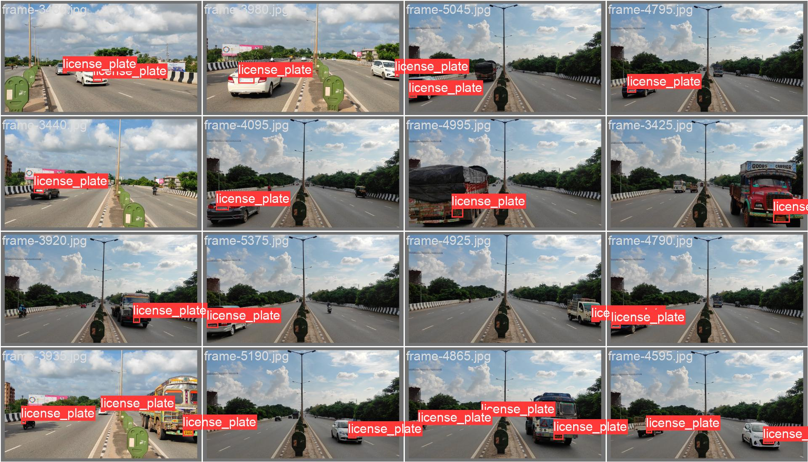

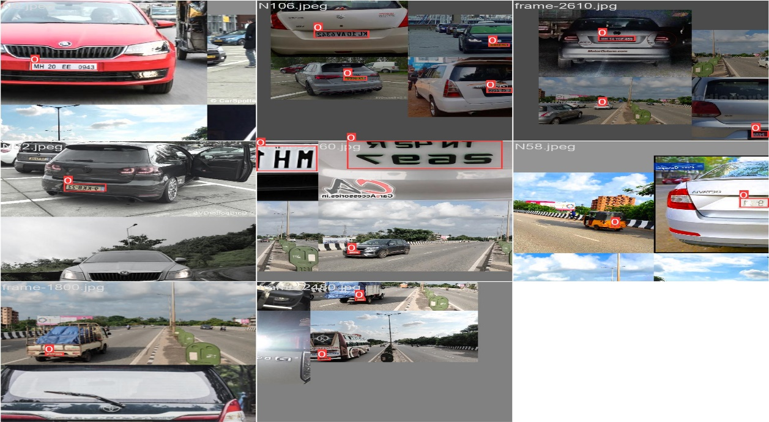

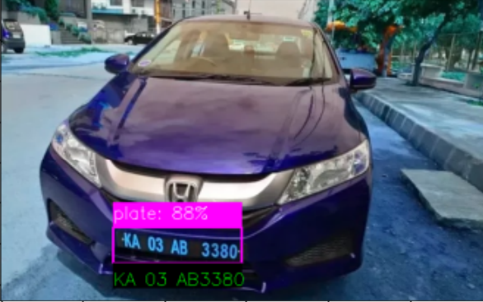 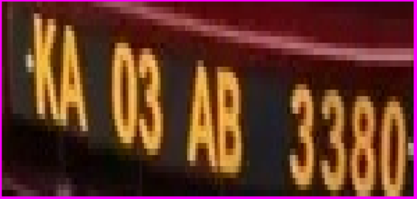

**Licence Plate Detection Licence Plate Extraction**

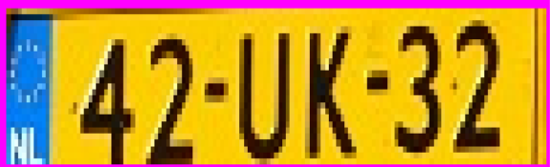 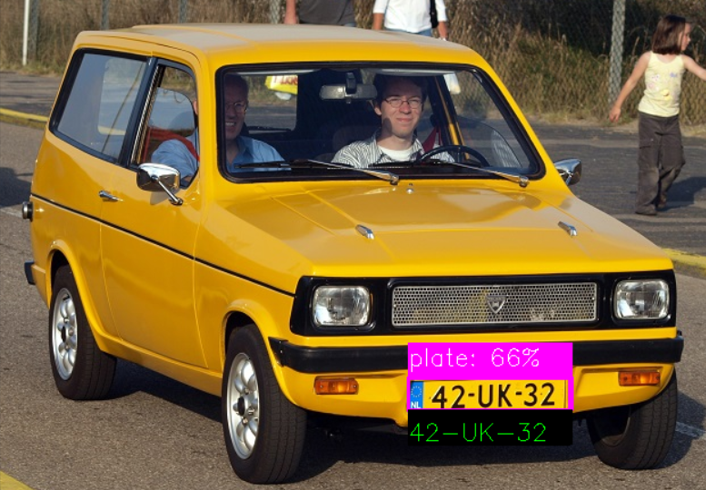

**Licence Plate Detection Licence Plate Extraction**

**CONCLUSION**

An efficient and layout-independent automatic license plate recognition (ALPR) system based on the YOLO detector has been developed. The YOLO detector is utilized to detect license plates accurately and efficiently, regardless of their layout and appearance. The system also includes a robust module for character segmentation and recognition, ensuring the accurate interpretation of characters on the detected license plates. Through this project's successful completion, a highly adaptable and versatile ALPR system has been achieved, with the potential to revolutionize computer vision and contribute to advancements in research and innovation.

 

**REFERENCES**

1."License Plate Detection and Recognition in Unconstrained Scenarios" by Z. Zhong, et al. (2019)

2."You Only Look Once: Unified, Real-Time Object Detection" by J. Redmon et al. (2016)

3."An Efficient and Accurate License Plate Recognition System using Convolutional Neural Networks and Optical Character Recognition" by V. Sriram et al. (2019)

 

+